* <https://www.ncbi.nlm.nih.gov/pmc/articles/PMC2856632/pdf/fneng-03-00003.pdf> - про диапазон, визуализация ряда, скалограммы
* <https://onlinelibrary.wiley.com/doi/full/10.1111/ner.12628> - визуализация ряда
* [Sensorimotor ECoG Signal Features for BCI Control: A Comparison Between People With Locked-In Syndrome and Able-Bodied Controls](https://www.ncbi.nlm.nih.gov/pmc/articles/PMC6805728/) - визуализация колебательной компоненты
* <http://www.schalklab.org/sites/default/files/misc/Brain-Computer%20Interfaces%20Using%20Electrocorticographic%20Signals_0.pdf>, <https://www.ncbi.nlm.nih.gov/pmc/articles/PMC4122137/> - визуализация в зависимости от типа движения руки
* Link to the Anastasia Motrenko code in the old repository <https://sourceforge.net/p/mlalgorithms/code/HEAD/tree/Group874/Motrenko2017ECoG/>
* M.-C. Schaeffer's thesis <https://tel.archives-ouvertes.fr/tel-01763451/document>
* <https://journals.plos.org/plosone/article?id=10.1371/journal.pone.0154878> - Penalized Multi-Way Partial Least Squares for Smooth Trajectory Decoding from Electrocorticographic (ECoG) Recording

Trace citation trees of the papers with “fronts” using WoK

Не нашла про статью A Long-Term BCI Study With ECoG Recordings

in Freely Moving Rats (нет доступа)

How to compute the power of a spectrogramme? We need a formula.

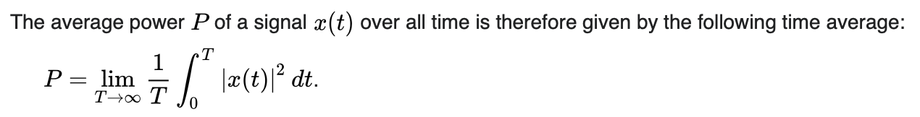

ссылка на википедию: <https://en.wikipedia.org/wiki/Spectral_density> (sure, the Parseval theorem is right about it.)

Plot two plots (for arbitrary ECoG time series):

1. power indicator set of a spectrogram (try to find a proper term and an algorithm),
2. spectrogram for one sensor,
3. spectrogram of several sensors in the neighbourhood? (place it together in the plot).

<https://colab.research.google.com/drive/1Vo87Gi42MqlWeEtVWid1rt1FuT_jtUPZ?usp=sharing>

Goal is to certify:

1. the main hypothesis is feasible (there is a baseline),
2. local models generate some useful features,
3. plot of data devivers us hope that the hypothesis could be tested.

On Thursday 22.10

1. Plot signal in time - spatial domain
2. Plot signal in time - frequency domain for each electrode

<https://colab.research.google.com/drive/19cP3EDUu7-KzjBUvWNTkrn-Bo3WW3-eD?authuser=1#scrollTo=StDPSVLhLwk5>

1. Give more general definition for local model

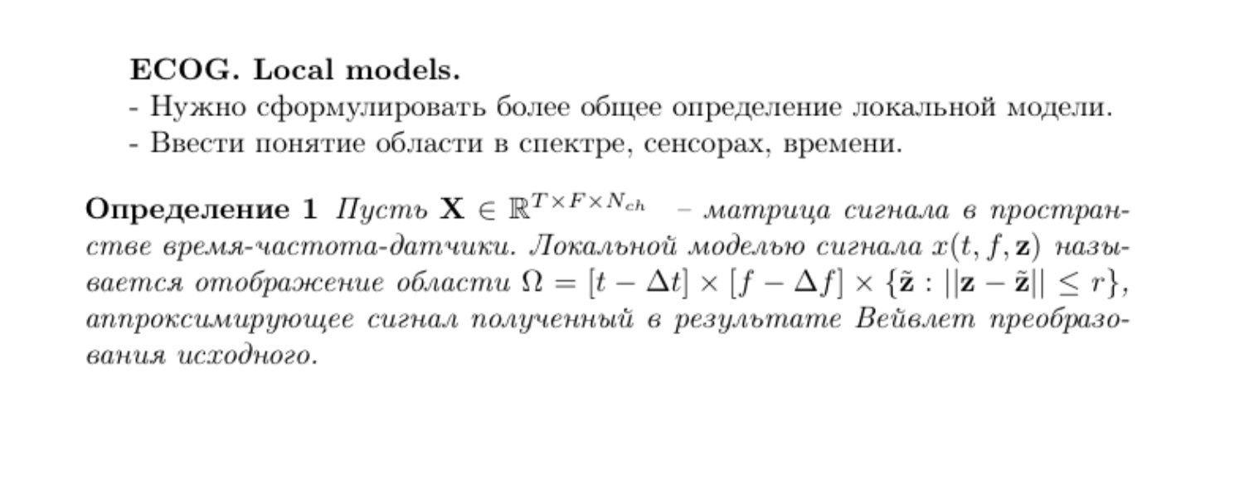

1. Find the NN for decoding task - In Progress

CNN -feature extraction, LSTM -prediction

<https://scholarship.miami.edu/discovery/delivery?vid=01UOML_INST:ResearchRepository&repId=12355465580002976#13355508200002976>